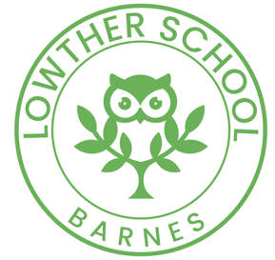
Reading together at home

1. Read together every day Reading with your child continues to be really important so keep reading lots of different books together. Most picture books will be too hard for a child of this age to read alone, but it’s good for them just to listen to a story or information book and talk about the pictures with you.

2. Allow some reading alone time Try a short reading time when you are reading (newspaper, magazine, book, on-screen) and your child is too. It’s good to start this habit of quiet reading time early, however short to begin with!

3. Talk about the book before you begin reading Before reading a book together, always talk about the title, the pictures and the information on the cover (front and back). If it’s new, ask what your child thinks the book might be about. If it’s an old favourite then talk about the bits you love most! Don’t worry if some books get chosen again and again!

4. Read with different voices When reading aloud use lots of expression and try different voices for different characters. Get your child to join in with bits too, such as, ‘They pulled and they pulled!’ and‘Fee, fi, fo, fom...’. See if your child can copy you!

5. Ask each other questions Talk about the stories and information books when you’ve finished reading together and ask questions. What did you like best? Why did the tiger let Floppy go? Have you ever played a trick on anybody? Get your child to ask you questions too.

6. Retell stories and events Ask your child about things that happened at school or with their friends. Sometimes, after you’ve shared a story or watched a TV programme, ask your child to tell you about it. Help them by asking What happened first? What next? And then what?

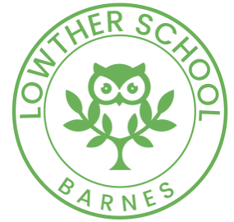
Early reading skills

1. Listen to your child read Your child might bring home decodable books from school. Designed to allow your child to learn how to read independently, these books help children apply their phonic skills – sounding out the words on the page. Be patient and be impressed!

2. Link letter sounds to letter shapes Your child will be learning letter sounds at school. Make sure you know how to say the sounds correctly . And don’t forget that some words, like said and the, are tricky and can’t be sounded out so keep pointing these out to practise them.

3. Looking at words and letters After you have read a book, play letter-spotting and word games like these with your child: Can you find Dan’s name on this page? Can you find the word ‘and’ on this page? How many words can you find on this page that begin with ‘t’? Get your child to ask you too!

4. Sound out first... If your child gets stuck on a word, check first if it can be sounded out or blended by saying the letter sounds individually and putting them together quickly to hear the word. If your child can’t work out the word, then you say it and move on.

