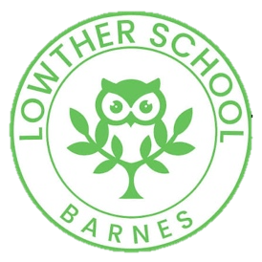

Early Years at Lowther Primary

In Early Years, our aim is to create a learning environment and build relationships which enable children to become confident, creative, and inquisitive members of the Lowther School Family. We strive to create well-rounded individuals who feel valued, have a deep love of learning and are ready and equipped to take on the next step of their learning journey.

During their two years with us, we want children to become:

• Competent and motivated learners who are curious about the world around them.
• Secure and resilient individuals who are equipped with problem solving skills and a strong sense of self-belief that enables them to bounce back from challenges and achieve well.
• Skilful communicators who are equipped with a vast and vibrant vocabulary and can connect with others through language.

Children in the Early Years learn in a stimulating and exciting setting, engaging in a mixture of playbased and adult directed activities. Through careful modelling from adults and appropriate challenge within the environment we encourage pupils to play and explore, engage in active learning, and create and think critically. Where possible our children are given the opportunity to learn through first-hand experiences, such as growing their own herbs to use in cooking or observing the hatching and growth of chicks.

Like the rest of Lowther School, we love outdoor learning in Early Years and our children can choose to learn either indoors or outdoors every day. We make the most of our own Nursery and Reception gardens alongside the school allotment, chickens, and wonderful grounds!

We work closely together with our parents and carers to provide a safe and happy start to school life, where families feel welcomed and included in their child’s learning. We do this through induction sessions, transition stay and play events and home visits. We also have specific times in which parents are invited in to share information with the class about their jobs, talents, cultures or hobbies.

We use an online system called ‘Tapestry’ to track children’s achievements and record ‘in the moment’ photographs of pupils’ learning. All children are observed regularly and learning experiences are then planned to meet the individual needs of children and develop their skills, knowledge and understanding further.

Our Nursery and our Reception classes follow the Early Years Foundation Stage statutory framework, supported by the non-statutory Development Matters. The EYFS educational programmes provide us with the curriculum framework which is then built upon to decide the wider learning content that best fits the interests and needs of our children. The curriculum is sequential, taking small steps and then broadening and deepening learning across a wide range of experiences. We teach a variety of planned topics based around carefully selected language-rich texts or cultural calendar events, and maximise opportunities for child-initiated learning, using the interests of individual pupils as a stimulus.

